Medical Image Segmentation and Applications
Lab- P2: Image Segmentation (EM Algorithm)

Faisal Farhan, Muhammad Kabir Hamzah, Diptan Regmi

1. Introduction and problem definition

The objective of this experiment is to develop from scratch an Expectation-Maximization algorithm for segmenting brain MRI images (T1-w image) into the three main tissues: white matter (WM), grey matter (GM) and cerebrospinal fluid (CSF). for a given dataset. A dataset containing brain MRI images of five different patients was given. Our goal of the experiment is to apply the Expectation-Maximization algorithm to i) assume mixture of Gaussians is a suitable model and ii) extend to process multivariate data. We implemented the algorithm in python to obtain the brain tissue segmentation (WM, GM, CSF) and then evaluated our outcomes with the given ground truth labels based on dice similarity score. The working procedure of the experiment and results are discussed in the next sections.

2. Design and Implementation

To conduct the experiment, we used python to implement EM algorithm from scratch for both single and multivariate data. The EM algorithm fundamentally uses 3 parameters namely; mean, variance (or covariance) and mixing coefficients for each tissue. First, we loaded the dataset that consists of two types of brain MRI images for each of the 5 patients. For each patient and for each modality, we used K-means to estimate the mean and variances for each brain tissue. These values are then set as the initial guesses for the EM algorithm to optimize for each modality and patient. The parameters obtained are shown in table-2.

Patient Number | Data Files
1 | T1.nii  T2_FLAIR.nii  LabelsForTesting.nii
2 | T1.nii  T2_FLAIR.nii  LabelsForTesting.nii
3 | T1.nii  T2_FLAIR.nii  LabelsForTesting.nii
4 | T1.nii  T2_FLAIR.nii  LabelsForTesting.nii
5 | T1.nii  T2_FLAIR.nii  LabelsForTesting.nii
Table-1: Dataset Description

 | Parameters for T1 images |  |  | Parameters for T2 images
 | CSF | GM | WM | CSF | GM | WM
Mean | 69.95 | 144.06 | 212.43 | 191.23 | 148.41 | 74.32 | Patient 1
Variance | 452.36 | 359.51 | 253.16 | 436.24 | 197.26 | 445.03
Mean | 58.96 | 126.12 | 179.43 | 86.40 | 208.12 | 165.91 | Patient 2
Variance | 339.89 | 253.34 | 209.44 | 589.97 | 849.25 | 208.34
Mean | 76.93 | 156.86 | 225.72 | 96.53 | 180.48 | 225.58 | Patient 3
Variance | 527.01 | 396.91 | 260.42 | 686.39 | 235.58 | 853.23
Mean | 74.16 | 150.33 | 220.33 | 75.77 | 191.97 | 153.77 | Patient 4
Variance | 482.77 | 366.96 | 252.77 | 494.38 | 265.18 | 204.55
Mean | 69.71 | 138.42 | 205.99 | 71.51 | 185.41 | 146.27 | Patient 5
Variance | 413.55 | 311.69 | 238.61 | 438.20 | 332.33 | 188.84

Table-2: Parameters obtained from K-means clustering

In the next step, the Gaussian Mixture Model (GMM) with the Expectation-Maximization (EM) algorithm is applied to segment brain MRI images into the three tissue types: Cerebrospinal Fluid (CSF), Gray Matter (GM), and White Matter (WM). We loaded MRI images, and their ground truth labels, both T1 and T2 FLAIR modalities, and used the ground truths to skull strip the brain images. The EM algorithm is then run to iteratively optimize the mean, variance, and mixing coefficients of the Gaussian components representing the tissues. Two components were used to stop or validate the convergence of the algorithm. The first is a finite number of iterations, set to 100. The other is the log likelihood tolerance which is calculated to monitor the convergence of the algorithm, we set the tolerance to 10e-6. Once the algorithm converges, the estimated parameters are used to classify voxels based on the highest probability from the GMM, segmenting the image into CSF, GM, and WM. The segmented images are saved, and the Dice coefficient is computed to evaluate the similarity between the segmented tissues and the ground truth for each tissue type. Finally, the segmentation results are visualized for analysis. The same procedure is followed for both single and multivariate data with the major difference being the computation of a covariance matrix for the multimodality instead of variance as in the single modality.

3. Experimental Section and Result Analysis

The given dataset consists of MRI brain images of five patients. For each patient data the ground truth is also provided. The segmented images for each patient data are illustrated in figure-3.

Segmented images for single model (T1)
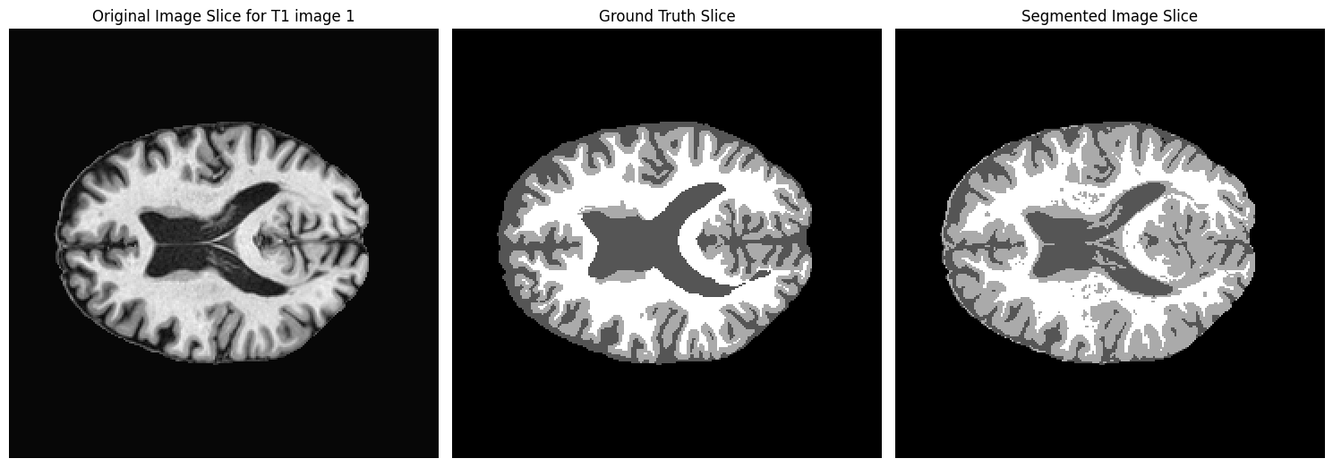
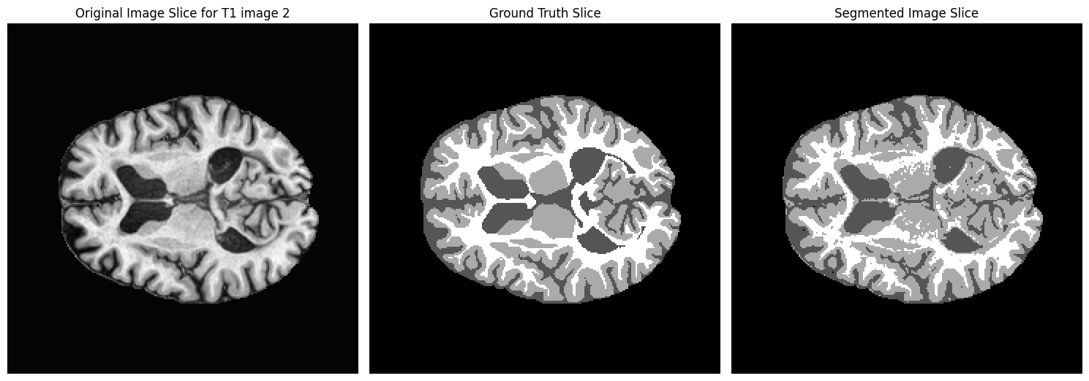
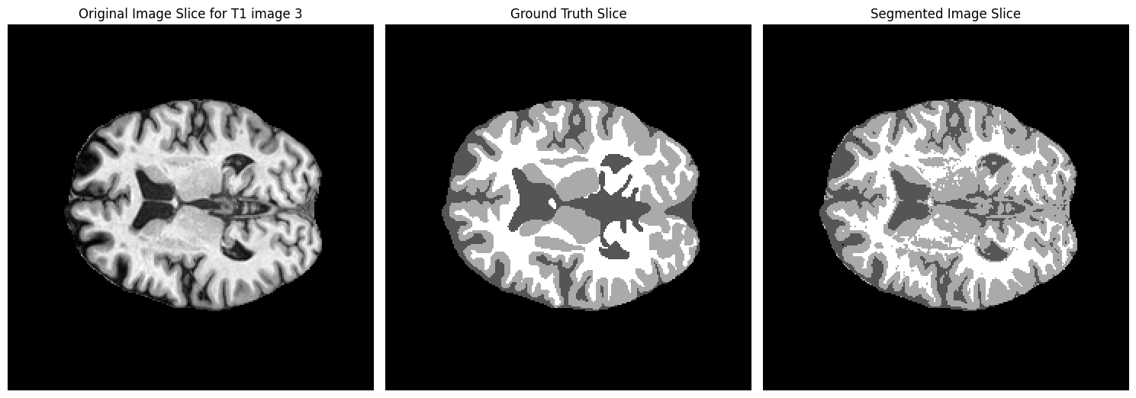
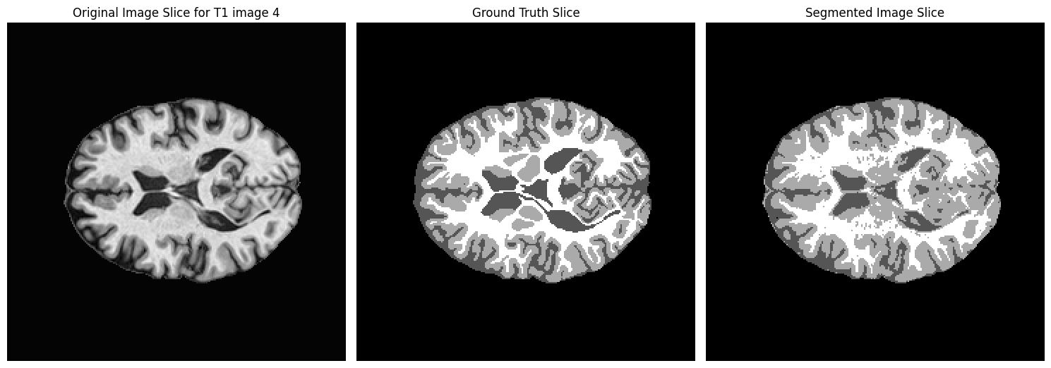
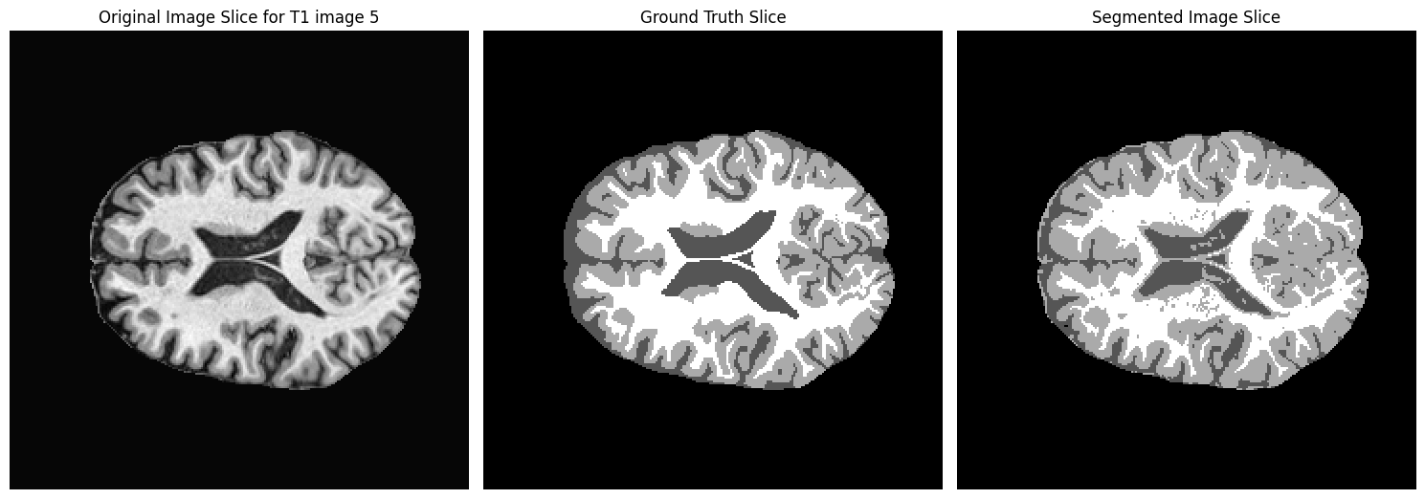

Segmented images for single model (T2)
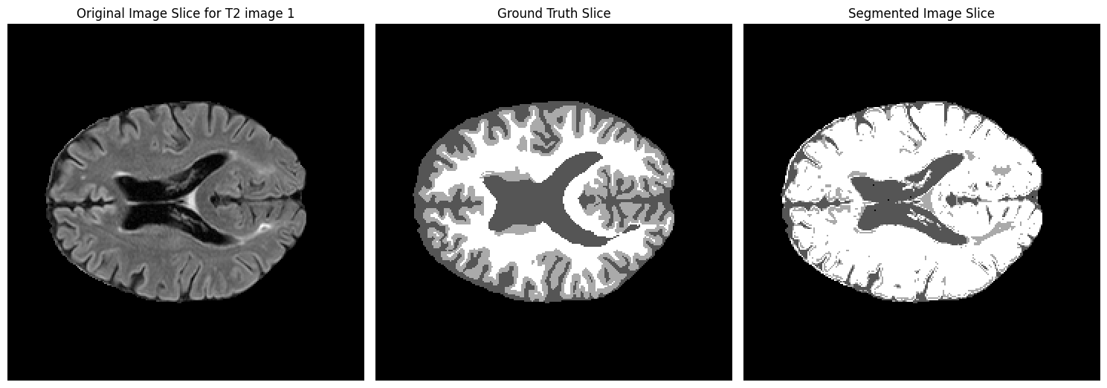
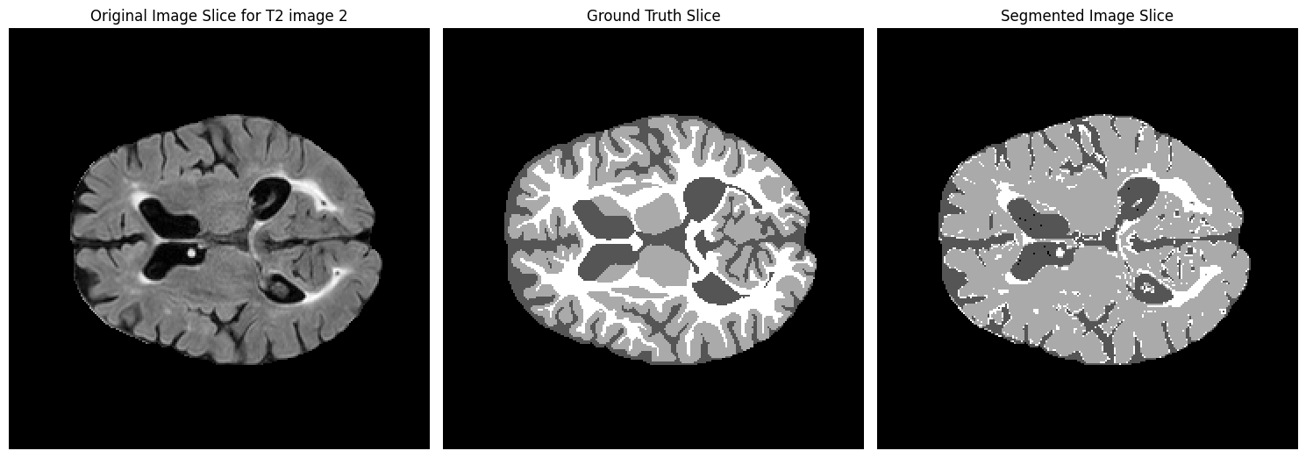
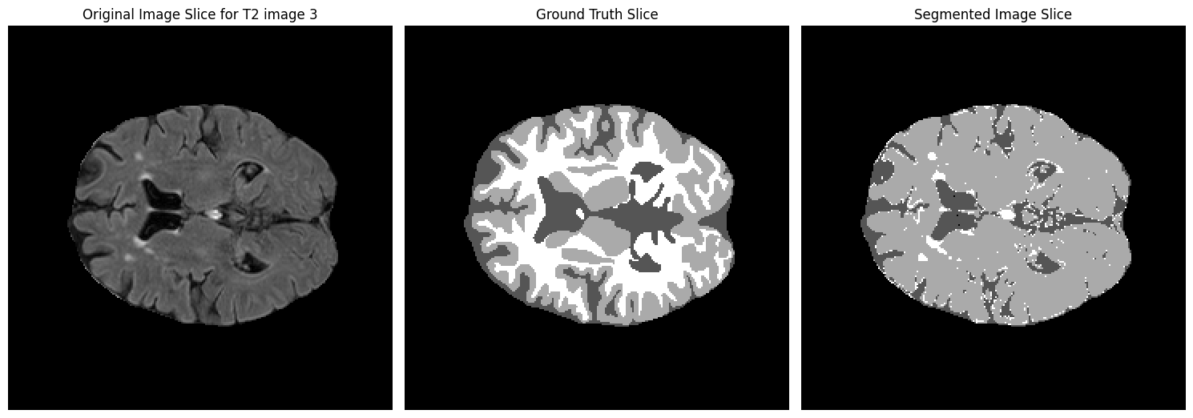
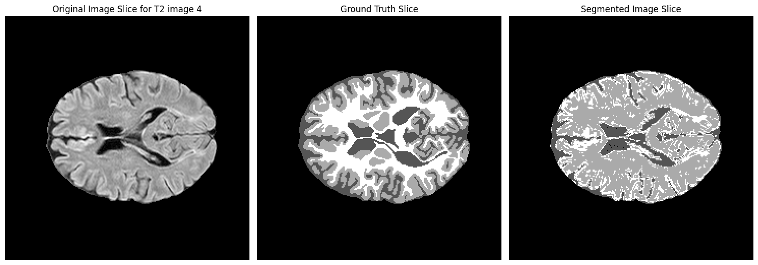
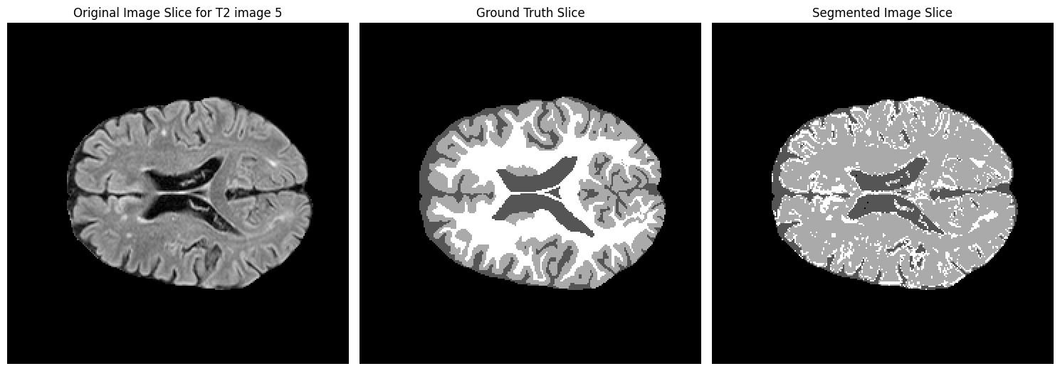

Segmented images for multi-modality
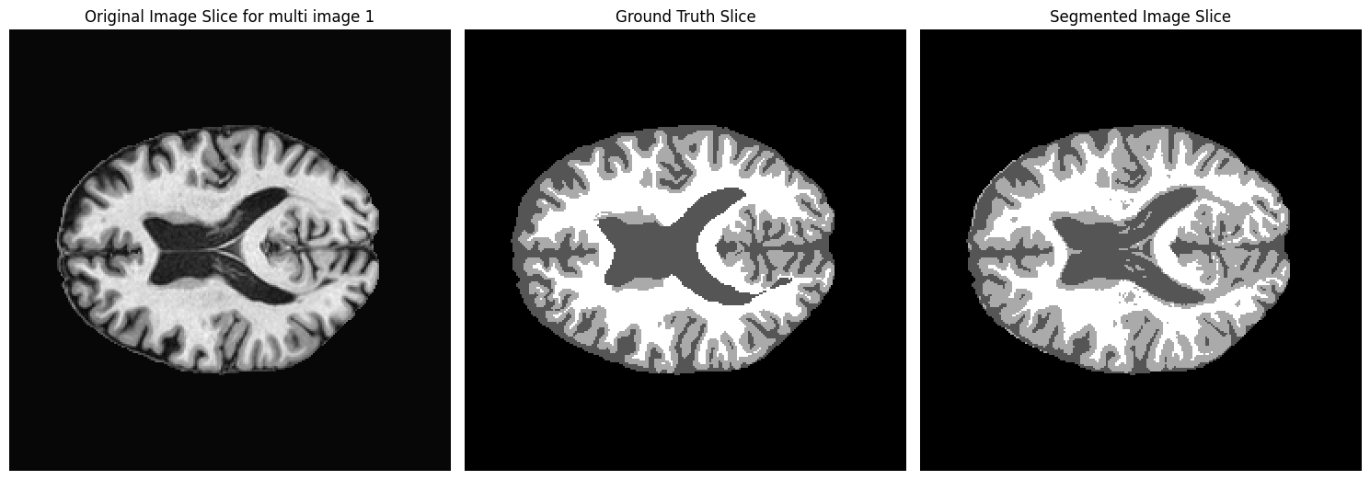
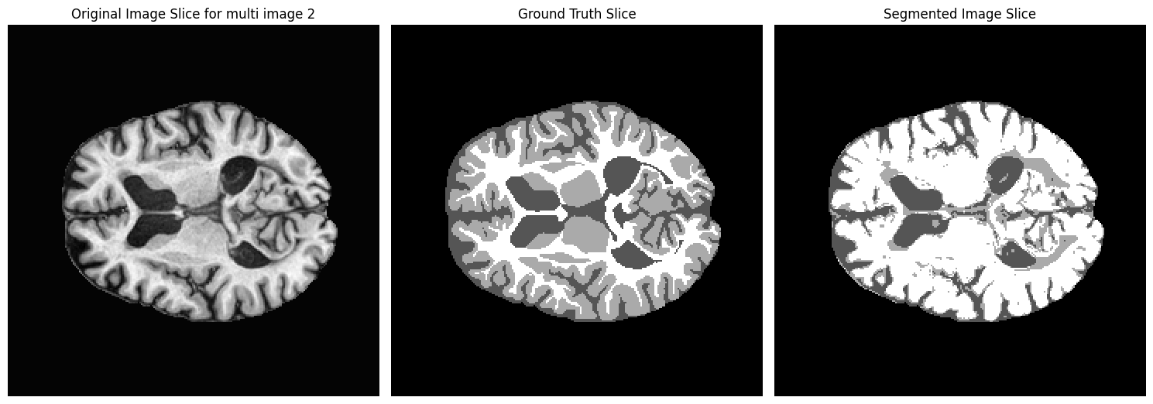
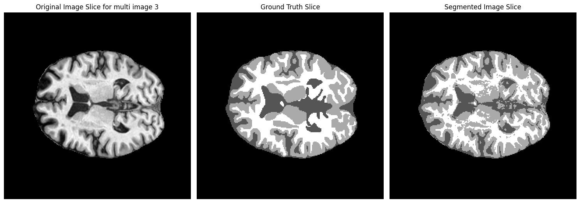
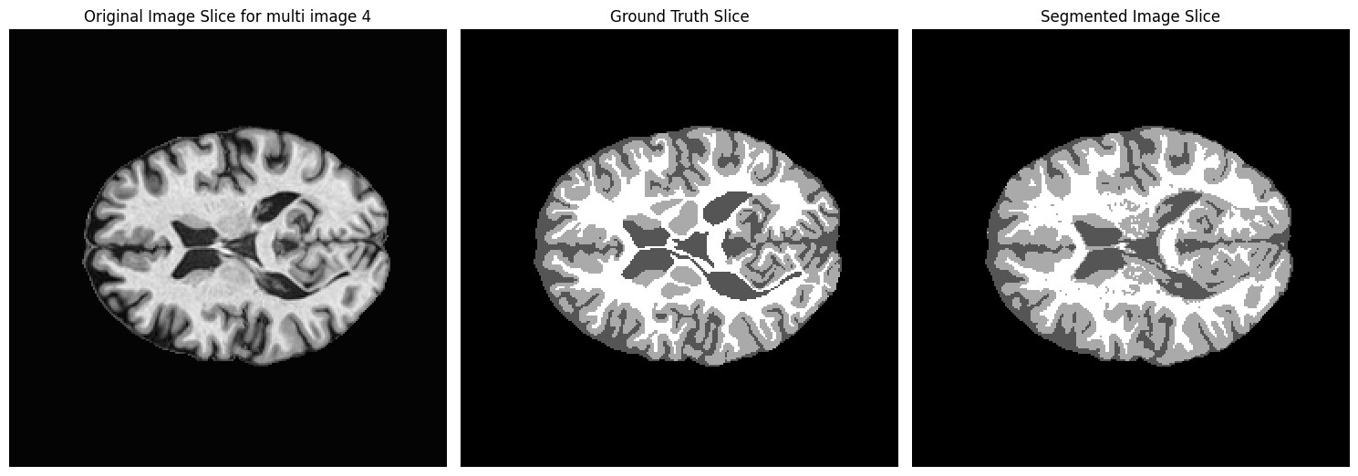
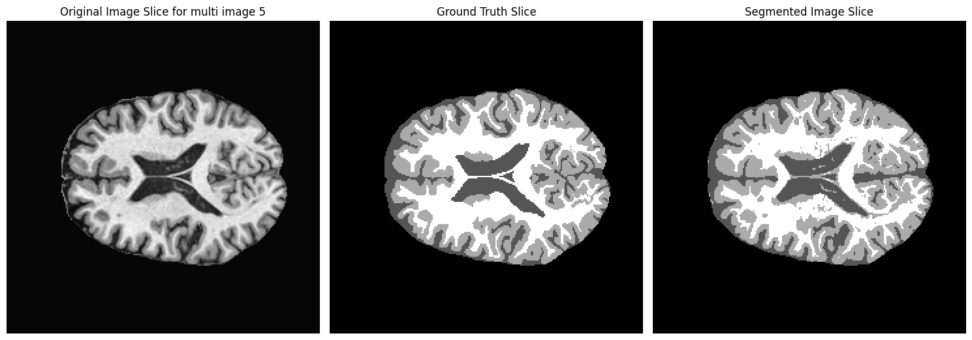

Figure-3: Original and Segmented Brain Tissue of each patient data

We evaluated the segmented labels with the given ground label truth using dice coefficient for each brain tissue (WM, GM and CSF). The results are shown in table-3 and 4 respectively.

Patient Number | Test Data | Segmented Tissues | Dice Scores | Average Dice | STD
Patient 1 | T1 | GM | 0.7731 | 0.8039 | ± 0.0459
 |  | WM | 0.8568
 |  | CSF | 0.7820
 | T2_Flair | GM | 0.1954 | 0.4585 | ± 0.2342
 |  | WM | 0.5358
 |  | CSF | 0.6443
Patient 2 | T1 | GM | 0.8024 | 0.8094 | ± 0.0390
 |  | WM | 0.7742
 |  | CSF | 0.8513
 | T2_Flair | GM | 0.7035 | 0.5626 | ± 0.3340
 |  | WM | 0.1813
 |  | CSF | 0.8032
Patient 3 | T1 | GM | 0.7769 | 0.8093 | ± 0.0314
 |  | WM | 0.8397
 |  | CSF | 0.8111
 | T2_Flair | GM | 0.6101 | 0.4598 | ± 0.3289
 |  | WM | 0.0825
 |  | CSF | 0.6868
Patient 4 | T1 | GM | 0.8071 | 0.8275 | ± 0.0367
 |  | WM | 0.8699
 |  | CSF | 0.8054
 | T2_Flair | GM | 0.5752 | 0.4886 | ± 0.2778
 |  | WM | 0.1778
 |  | CSF | 0.7128
Patient 5 | T1 | GM | 0.8478 | 0.8460 | ± 0.0227
 |  | WM | 0.8210
 |  | CSF | 0.8025
 | T2_Flair | GM | 0.6167 | 0.4941 | ± 0.3268
 |  | WM | 0.1237
 |  | CSF | 0.7419

Table-3: Dice Scores of segmented tissues for patient data (T1 & T2 individual)

Patient Number | Segmented Tissues | Dice Scores | Average Dice | STD
Patient 1 | GM | 0.8219 | 0.8594 | ±0.0356
 | WM | 0.8497
 | CSF | 0.9066
Patient 2 | GM | 0.1887 | 0.5197 | ±0.2862
 | WM | 0.5286
 | CSF | 0.8417
Patient 3 | GM | 0.7786 | 0.8237 | ±0.0306
 | WM | 0.8374
 | CSF | 0.8549
Patient 4 | GM | 0.8398 | 0.8697 | ±0.0243
 | WM | 0.8686
 | CSF | 0.9008
Patient 5 | GM | 0.8464 | 0.8671 | ±0.0134
 | WM | 0.8890
 | CSF | 0.8659

Table-4: Dice Scores of segmented tissues for patient data T1 & T2 (multimodal)

We observed that the dice coefficient obtained from patient two is comparatively low. Investigations show that white matter lesions of that patient as seen in the T2_FLAIR image appear hyperintense hence the misclassification. The reverse (hypointense) is the case for the same tissue in the T1 weighted patient image.

4. Project Management details

In this project, the primary tasks involved developing the Expectation-Maximization (EM) algorithm from scratch, implementing it to segment brain MRI images, and evaluating the results. The project was divided into several key steps. First, the setup and initialization of the algorithm and datasets, including loading the MRI data and setting up initial parameters using K-means clustering, were estimated to take around 2-3 hours but took about 4 hours due to additional preprocessing steps. The implementation of the EM algorithm itself, including applying it to both single and multivariate data, was initially planned for 4-5 hours but extended to approximately 6 hours as adjustments were made to the algorithm for multivariate processing. Evaluating the segmentation results with ground truth labels using the Dice similarity score and visualizing the outcomes required an additional 2-3 hours due to testing and validation of different cases. Overall, the project was completed in approximately 12 hours, exceeding the original estimation due to unexpected tuning and testing requirements.

5. Conclusion

In this experiment, we successfully implemented the Expectation-Maximization (EM) algorithm from scratch and applied it to segment brain MRI images into three tissue types: White Matter (WM), Gray Matter (GM), and Cerebrospinal Fluid (CSF). The algorithm was applied to both single and multivariate datasets, and the results were evaluated using the Dice similarity score. The evaluation revealed that the segmentation of WM consistently produced better results compared to GM and CSF, with higher Dice scores, particularly for T1 images. While the results were promising, especially for WM segmentation, there is still room for improvement, particularly in the segmentation of GM and CSF. The project also demonstrated the effectiveness of using the Gaussian Mixture Model with EM for tissue classification in medical imaging. This experiment provided a deeper understanding of the EM algorithm and its practical applications in neuroimaging.

